The process is called Transpose.

Select a table in your spreadsheet Copy (CTRL+C)
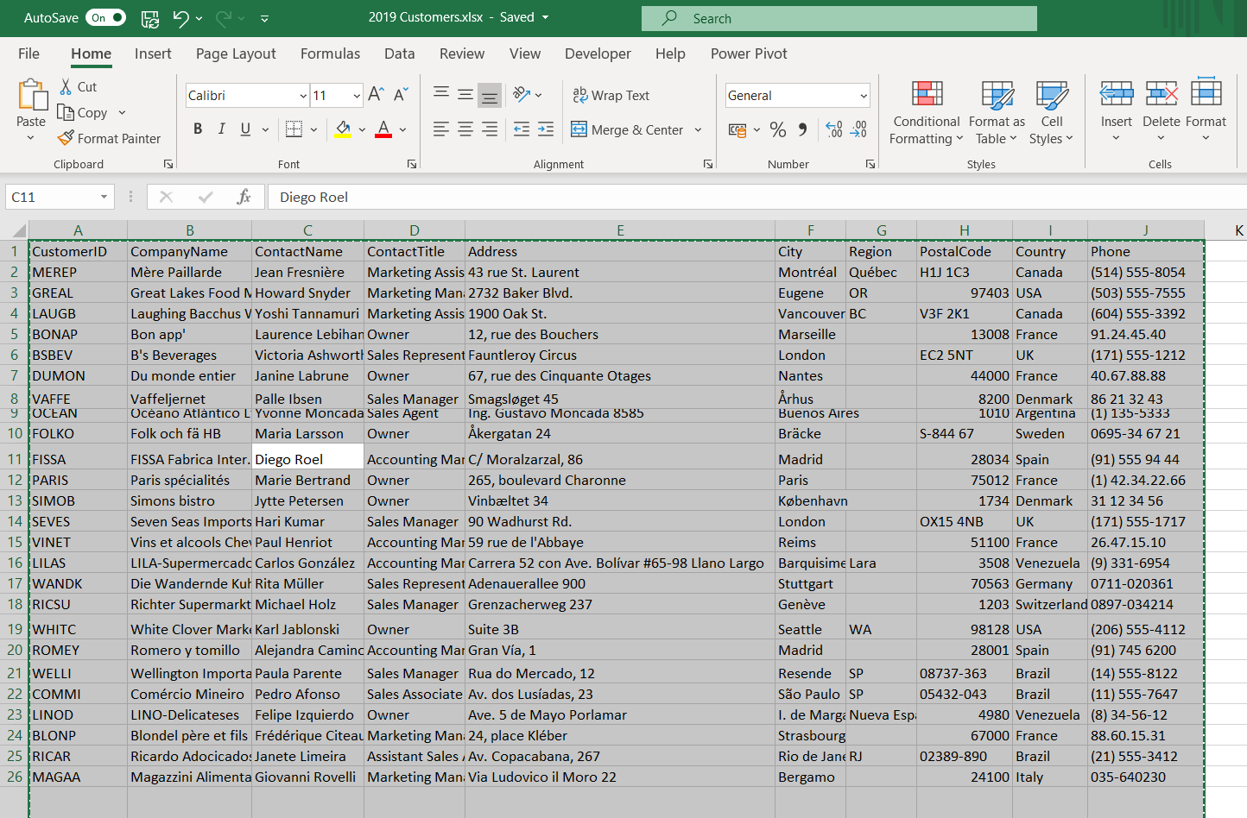
Select a new sheet
Right click the cell to paste from and click on the Paste Special (Don’t hover over it, click it)
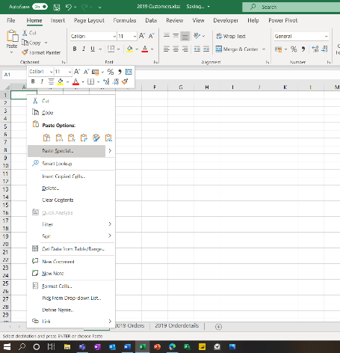
This will open the Paste Special dialogue box Click Transpose
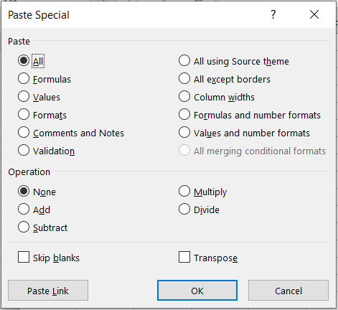
Click OK and the list (Or a selected column or a selected row) will be layed out in a transposed way.
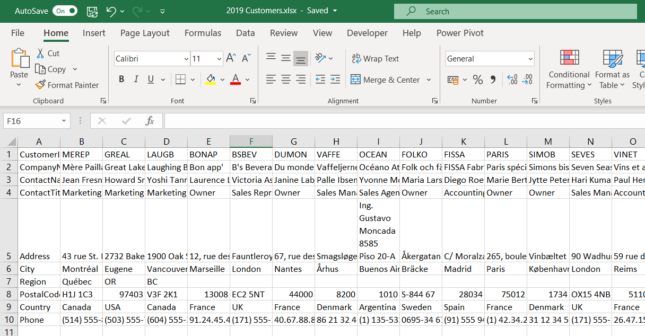
Process complete!

